**COVID-19 and Prisons**

*STATS 141XP*

Emily Allendorf, Luis Ceja Abrica, Tiffany Feng, Amarissa Mases, Newton Peng, Lizbeth Ureno, Kienna Qin, Varchasvi Vedula

#### **Abstract**

We investigate 1) how criminal justice outcomes (i.e. prison demographics, county-wide COVID-19 statistics) are reflected through COVID-19 in prisons and 2) how prisons are similar to universities in the context of COVID-19 prevalence in shared living spaces. We used hierarchical multiple linear regression modeling and Bayesian generalized linear models in order to study our research questions of interest. Our hierarchical regressions indicate that the staffed capacity, design capacity, and percentage occupied in the prison; female, male, and white prison admission rates; and county-level case and death rates of COVID-19 are significantly related to resident and staff case rates in prisons given that the other respective case rate (resident / staff) lagged by one day was included as a predictor in the model. Moreover, our ANOVA test concluded that adding the other respective lagged case rate as a predictor was significant for both hierarchical regressions, with p-values approximately equal to 0. Our Bayesian generalized linear mixed effects models indicate that cumulative resident case count is Poisson distributed and suggests date, staffed capacity, and percent occupied are statistically significant predictors of the cumulative number of confirmed resident cases in a prison.

These findings help illustrate that prison capacity levels, prison demographics, and county-level COVID-19 rates have significantly and differentially influenced prison staff and resident case rates in California over the course of the pandemic. In addition, more crowded facilities are not necessarily connected with higher covid case counts, suggesting that some facilities may be better equipped to handle a pandemic, regardless of size. Finally, our results indicate a strong relationship between prison staff and resident cases. Therefore, as colleges plan to open up, they should consider these factors to implement extra precautions in residence halls to deter the spread of COVID-19 between roommates, staff, and other residents. Our access to current and sufficient datasets were limited, which raised concerns regarding the accuracy of our analysis and prompted us to limit the scope of our research to only prison facilities in California, as well as only studying COVID-19 case rates rather than death rates. This required creative solutions such as subsetting for certain dates and filling in missing data. In the future, we hope to expand our project to include more facilities besides prisons, as well as more states rather than just California. We also hope to locate more current, updated datasets in order to provide more reliable analyses.

#### **Statement of the Problem**

There’s been a sharp spike in the spread of COVID-19 in prison facilities since the start of the pandemic. Seeing as this is a severe public safety issue, we seek to explore what factors contribute to the transmission of the virus and which groups are more probable of contracting the virus in confined spaces. In addition, due to the limited size of cells and mass incarceration of people, heavy interaction between staff and residents is inevitable. The small size of dorm rooms and influx of college students mirrors this issue. Thus, we seek to investigate the severity of COVID-19 in confined and overcrowded areas where social distancing isn't possible (Widra 2020; Kajstura and Landon 2020).

Therefore, we hope to study two research questions:

1. How are criminal justice outcomes reflected through COVID-19?
   1. How factors like demographics and county-level COVID-19 statistics are reflected in COVID-19 case rates in prison facilities.
2. How are prisons similar to universities in the context of COVID-19?
   1. How variables such as prison capacity and occupancy affect COVID-19 case rates in prisons, and what this can mean for universities.

#### **Data, Variables, and Schematic**

###### **Data:**

We compiled four datasets for our analysis:

1) Prison COVID-19 Data: Our main dataset comes from UCLA Law’s COVID-19 Behind Bars Data Project, which produces a dataset containing daily counts of COVID-19 over more than 1,700 state, federal, county, and immigration correctional facilities in the U.S.

2) Prison Population Data: To get accurate population and capacity information for each prison facility, we used weekly reports from the California Department of Corrections and Rehabilitation (CDCR), which contained relevant population and capacity variables for prisons in California.

3) Demographic Data: Our data on prison demographics came from the Vera Institute, which contained county-level data on incarceration trends, such as admission rates across genders, race/ethnicities, etc.

4) County-Wide COVID-19 Data: Lastly, we used a dataset from the California Department of Public Health, which contained daily county-wide COVID-19 statistics across the U.S.

Our final dataset consisted of over 9500 observations with 16 variables, containing data on 33 prison facilities in California.

###### **Variables:**

| **Variable** | **Type** | **How It’s Measured** | **Units** |
| --- | --- | --- | --- |
| Facility name | Categorical | -- | -- |
| Date of case counts | Date | -- | -- |
| COVID case count (Residents) | Numerical | cumulative resident cases | 1 |
| COVID case rate (Residents) | Numerical | (cumulative resident cases) / (# of residents) | 1 |
| COVID case count (Staff) | Numerical | cumulative staff cases | 1 |
| COVID case rate (Staff) | Numerical | (cumulative staff cases) /  (# of staff) | 1 |
| Total Population | Numerical | -- | 1 |
| Staffed Capacity | Numerical | -- | 1 |
| Design Capacity | Numerical | -- | 1 |
| Percent Occupied | Numerical | (Total Population) / (Design Capacity) | 1 |
| Gender | Categorical | -- | -- |
| Prison Admissions Rate (Female) | Numerical | -- | 0.01 |
| Prison Admissions Rate (Male) | Numerical | -- | 0.01 |
| Prison Admissions Rate (White) | Numerical | -- | 0.01 |
| County COVID case rate | Numerical | (Cumulative # of COVID cases in a county) /  (County population) | 1 |
| County death rate | Numerical | (Cumulative # of COVID deaths in a county) /  (County population) | 1 |

*Table 1: Variables of Interest*

###### Our data is structured both at the prison level and the county level, with prison demographic and COVID-19 data collected for each state prison. We also included county-level COVID-19 case counts and death counts for the county in which each prison resides.

Our data also includes time-dependent and time-independent variables. All COVID-19 case counts and death counts, occupation percentages, and staffed capacities are collected on daily or near-daily intervals. Meanwhile, some facility characteristics like capacity, gender, male and female ADM rate, and white ADM rate are collected once for each facility.

|  | **Date** | 3/31/20 | 4/1/20 | 4/2/20 | ... | 4/21/21 | 4/23/21 | 4/25/21 | **Time-Independent Variables** | | | | |
| --- | --- | --- | --- | --- | --- | --- | --- | --- | --- | --- | --- | --- | --- |
| **Facility** | **Time Dependent**  **Variables** |  |  |  |  |  |  |  | **Capa-**  **city** | **Male Prison ADM Rate** | **Female Prison ADM Rate** | **White Prison ADM Rate** | **Gen-der** |
| Avenal State Prison | ... |  |  |  |  |  |  |  | 2920 | ... | ... | ... | Male |
| ... |  |  |  |  |  |  |  |  |  |  |  |  |  |
| California Health-  care Facility | Resident Case Count | 0 | 0 | 0 | ... | 621 | 621 | 621 | 2951 | 0.273418 | -0.54632 | -0.23604 | Male |
| Staff Case Count | 1 | 1 | 1 | ... | 661 | 661 | 663 |
| Percent Occupied | 96 | 96 | 96 | ... | 82.7 | 82.7 | 82.7 |
| Staffed Capacity | 2951 | 2951 | 2951 | ... | 3051 | 3051 | 3051 |
| County COVID case rate | 0.000298 | 0.000318 | 0.000332 | ... | 0.09090 | 0.09105 | 0.09117 |
| County COVID death count | 0.000012 | 0.000013 | 0.000014 | ... | 0.00173 | 0.00173 | 0.00173 |
| ... |  |  |  |  |  |  |  |  | ... | ... | ... | ... | ... |
| Substance Abuse Treatment Facility | ... |  |  |  |  |  |  |  | 3424 | ... | ... | ... | Male |

*Table 2: Structural Relationship of Variables*

#### **Exploratory Data Analysis**

###### **Visualizations:**

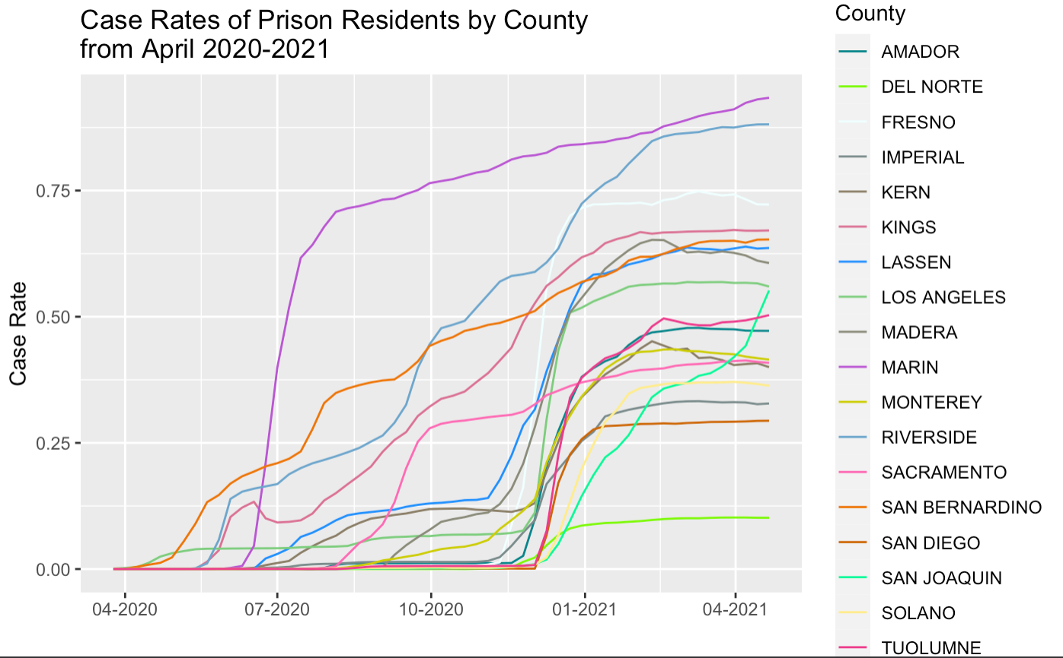

*Fig 1: Graph of Prison Resident Case Rates by County*

Figure 1 represents prison resident case rates for facilities in each county in California from April 2020 to 2021. The case rates were aggregated to the county-level by calculating the average case rates for facilities in each county over time.

From the graph, we see that the counties with the highest resident case rates are: Marin, Riverside, and Fresno, and the counties with the lowest resident case rates are: Del Norte, San Diego, and San Joaquin.

We also produced the same graph, but for prison staff case rates instead:

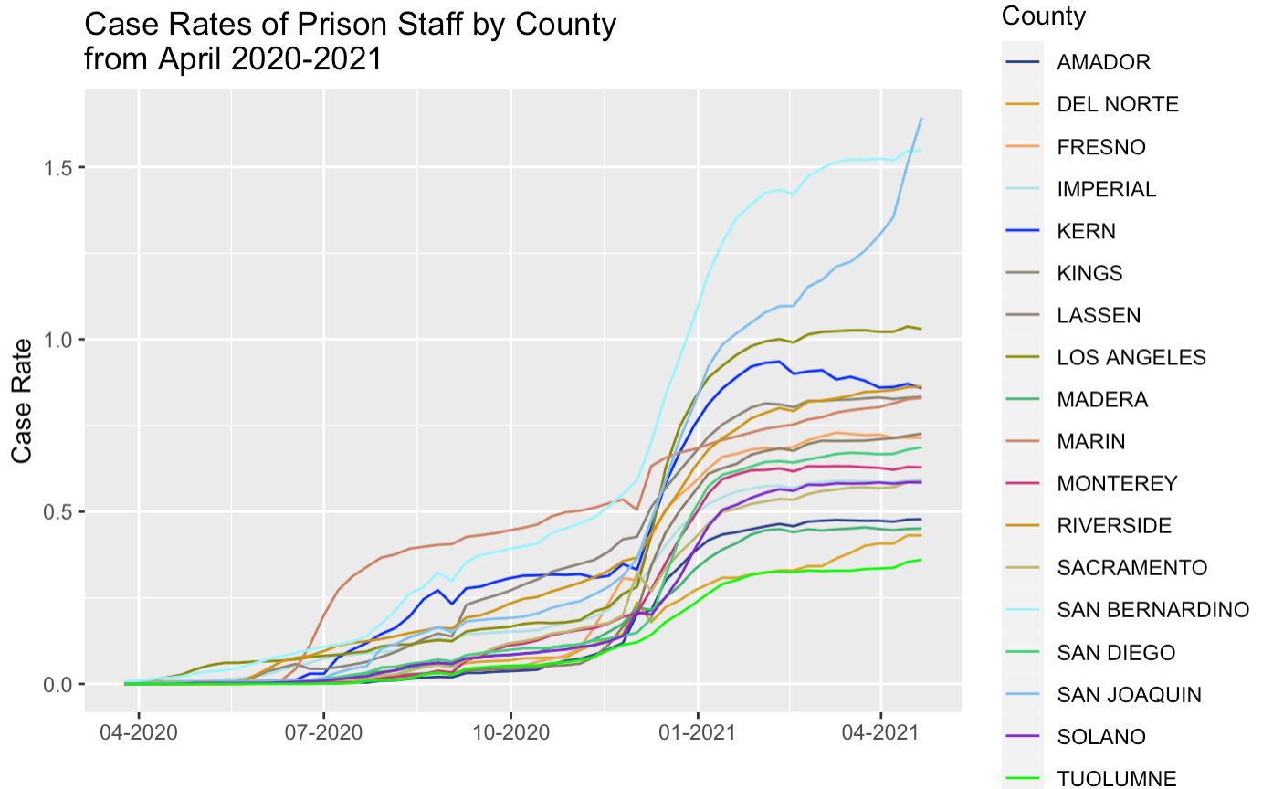

*Fig 2: Graph of Prison Staff Case Rates by County*

Figure 2 shows that the counties with the highest staff case rates are: San Bernardino, San Joaquin, and Los Angeles, and the counties with the lowest staff case rates are: Tuolumne, Del Norte, and Madera.

It is interesting to think about why some counties might have higher resident / staff case rates than others, which is why we investigate whether county-level COVID-19 statistics are reflected in prison case rates later in our report.

We were also interested in investigating the relationship between prison resident and staff case rates, so we created a time series plot of the average resident and staff case rates for all facilities from April 2020 to April 2021.

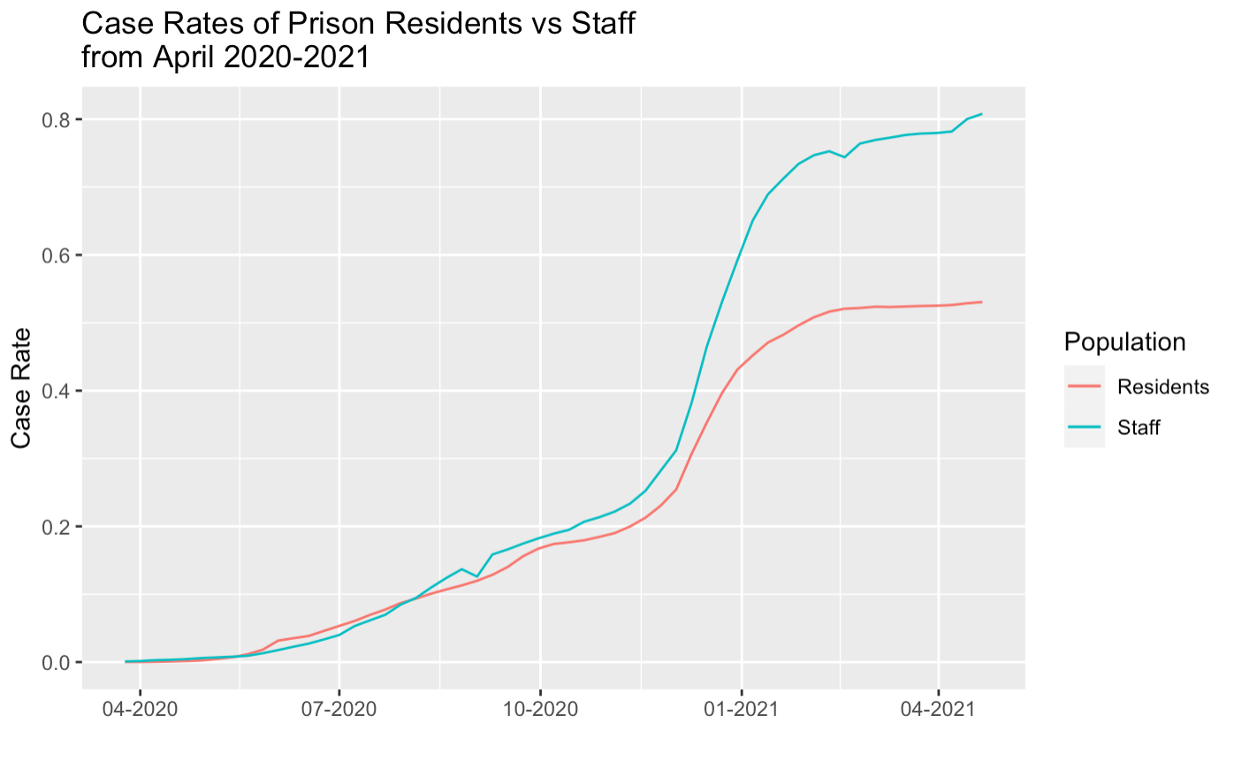

*Fig 3: Graph of Prison Resident Case Rates vs. Staff Case Rates*

From the graph, we can see that staff and resident case rates follow a similar pattern, although the curve overlaps each other around late August 2020, where staff case rates start to surpass resident case rates, which continues until April 2021. We were interested in investigating the relationship between resident and staff cases further, as in seeing if we could determine who is infecting who, so we decided to conduct a cross-correlation analysis.

###### **Cross-Correlation Analysis:**

A cross-correlation analysis involves investigating the correlation between two different sequences. Performing a cross-correlation analysis is simple and works like autocorrelation with two vectors instead - we take the y-variable with the values for each day and we take the x-variable with corresponding values for each day. In this case, the y-variable is the change in resident case rates per day and the x-variable is the change in staff case rates per day. We then shift the x-variable (e.g. shifting by -1 means placing the current values one day before) and correlate these shifts with the y-variable kept at its usual dates. Conducting a correlation on different days with our variables, we obtain the following table with 10 total lags:

| Lags: | -5 | -4 | -3 | -2 | -1 | 0 | 1 | 2 | 3 | 4 | 5 |
| --- | --- | --- | --- | --- | --- | --- | --- | --- | --- | --- | --- |
| Corr. | 0.38 | 0.31 | 0.39 | 0.58 | 0.58 | 0.45 | 0.30 | 0.37 | 0.40 | 0.33 | 0.30 |

*Table 3: Table of Correlations for 10 Lags*

Table 3 shows that the highest correlations occur when we lag staff by -1 and -2, which implies that high values of staff infections lead to high values of resident infections approximately one or two days later.

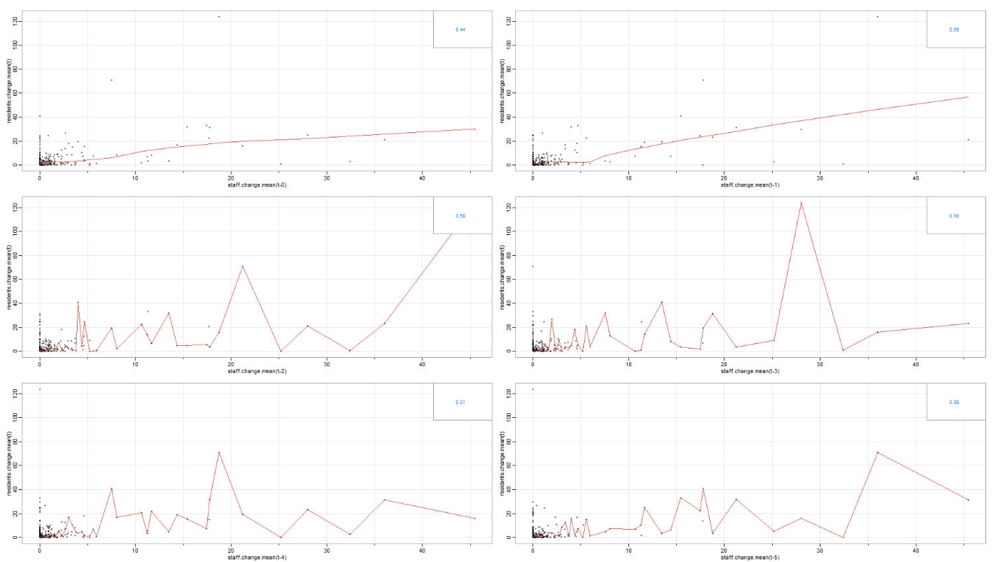

*Fig 4: Scatterplot of Lags. Correlation Coefficient is shown in the upper right of each; lag number is displayed on the x-axis*

Figure 4 shows a scatter plot with different lags on the changes in staff cases displayed by the x-axis and the changes in resident cases on the y-axis. This further supports the two lags mentioned above, as the others have too much variation in simultaneous large values or small values.

***R0 Analysis:***

We did a preliminary analysis of the spread of COVID-19 using a metric called R0. R0 is an epidemiological term which is defined as the average number of secondary cases of a disease caused by a single infected individual over their infectious period. We use a software package named EpiEstim in R, which is designed to model time-variant R0.

This analysis was conducted using the data about the number of active cases on each day starting from June 1st 2020 till April 25th, 2021. This model requires some context about the Serial Interval of the COVID-19, which is the time interval between the onset of symptoms in the primary and secondary case. We found this data from the study by Rai et al. We compare the R0 models for a particular facility (Adelanto ICE Detention Center) to that of the county it is in (San Bernardino County) to see if the spread rate is different between the two facilities.

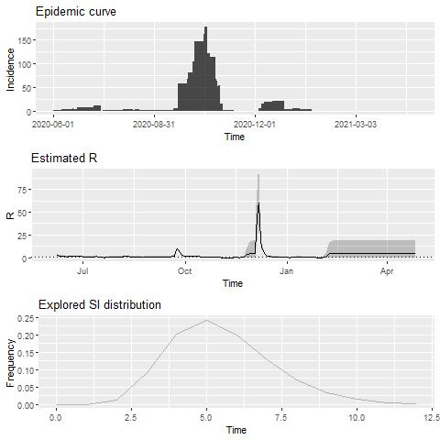

*Fig 5: R0 model of Adelanto ICE Detention Center*

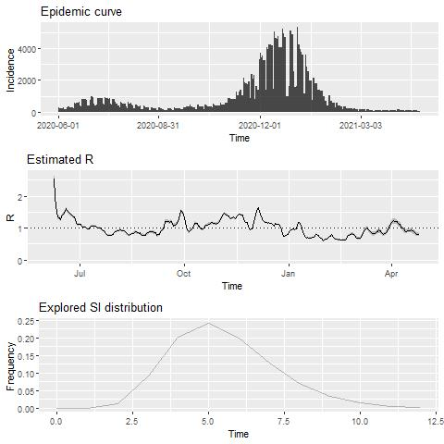

*Fig 6: R0 model of San Bernardino County*

Figure 5 represents the model results of the facility, while Figure 6 represents the county. In each of the figures, the top subfigure represents the number of active cases through time, while the second subfigure displays the R0 estimates through time. For most of the time, R0 is around 1, which shows a roughly linear growth. This means that on average, an infected person infects approximately one other person.

We note that there have been 2 major spikes in the covid case rates in the facility, around October 2020 and December 2020. These spikes correspond to highly pronounced R0 in the facility, where R0 jumps as high as 60, meaning that an average infected person infects 60 other people. However, the spikes are not nearly as pronounced in the county in general. This suggests that during an outbreak in cases, the spread rate of COVID is likely to be higher in prisons than it would be outside.

This pattern showed up in other facilities too, where R0 jumps up to at least 10 in October and December 2020, while the county’s estimate wavers around 1 to 2. A future study could choose to statistically compare all facilities with their counties and perform a hypothesis test to see if the R0 time series are statistically different.

#### **Statistical Analysis**

###### **Hierarchical multiple linear regression models:**

First, we created hierarchical multiple linear regression models to study how 1) demographic factors and 2) county-wide COVID-19 statistics related to covid outcomes in prisons. Hierarchical regression is where you fit sequential regression models that each add on more and more predictors in order to study the different effects your variables of interest have on the dependent variables. We decided to use multiple linear regression models since we wanted to model multiple independent variables against one dependent variable, all numerical, and it was also the most interpretable model.

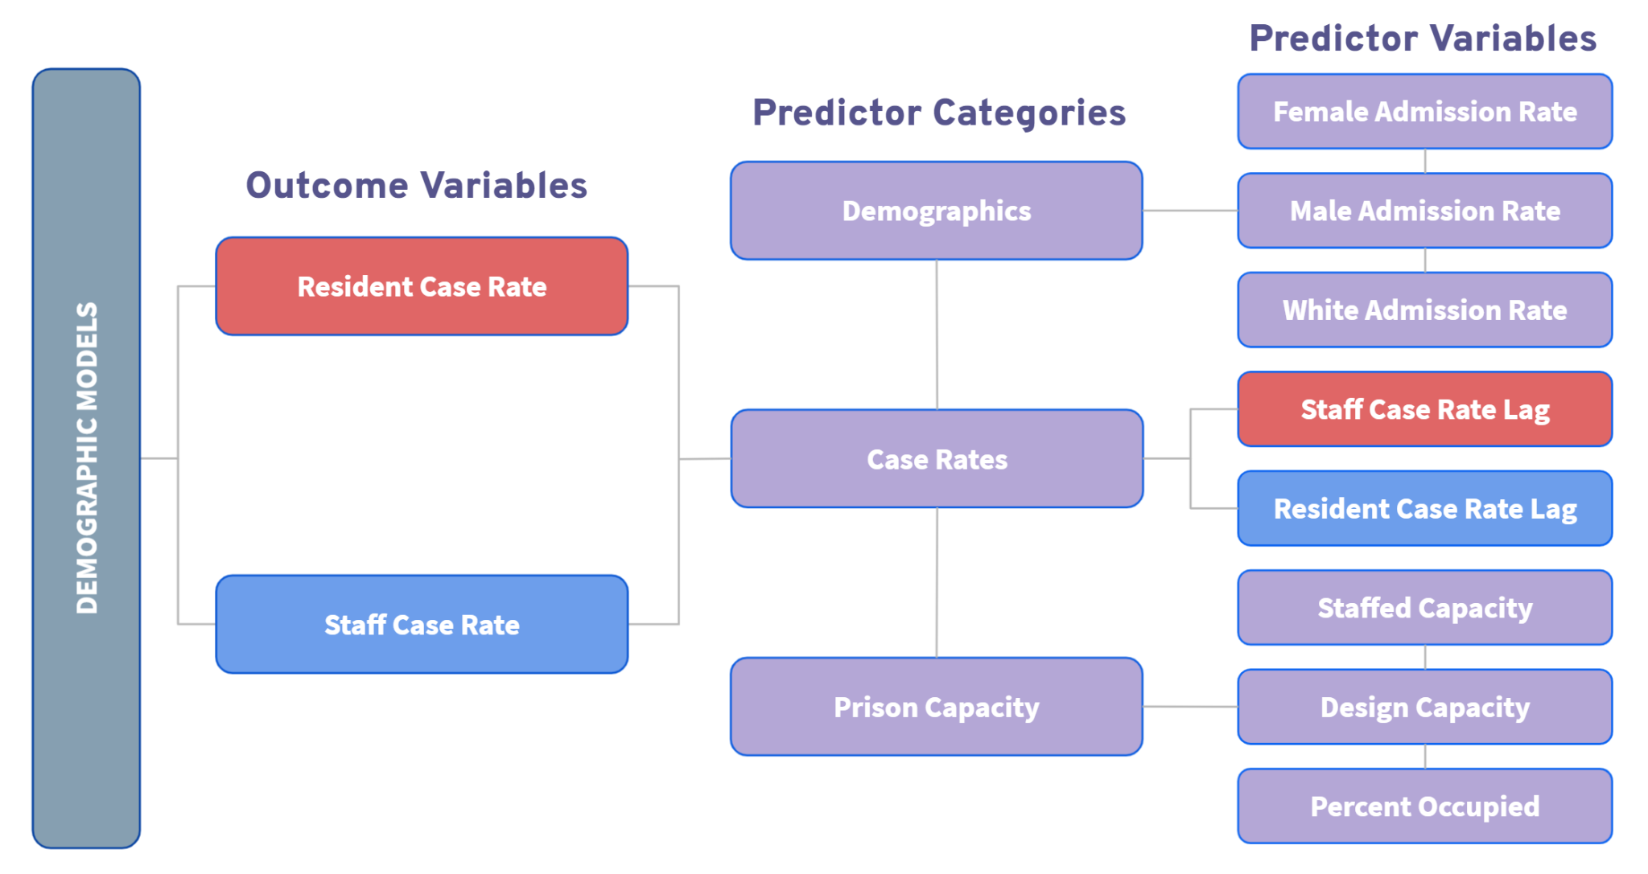

*Fig 7: Schematic of Hierarchical Regression Models with Demographic Predictors*

We first studied how demographic predictors related to resident and staff case rates in prisons. We produced two models, as shown in Figure 7: one with resident case rates as the outcome, and another with staff case rates as the outcome. Then, we split our predictor variables of interest into 3 categories: 1) those related to demographics, which were female, male, and White prison admission rates, 2) those related to case rates, where we added the other respective case rate for each outcome variable lagged by one day as we saw earlier in the cross-correlation analysis, and finally, 3) those related to prison capacity, which were staffed and design capacity, and percent occupied in the prison. We fit each category of predictors sequentially for our hierarchical regressions.

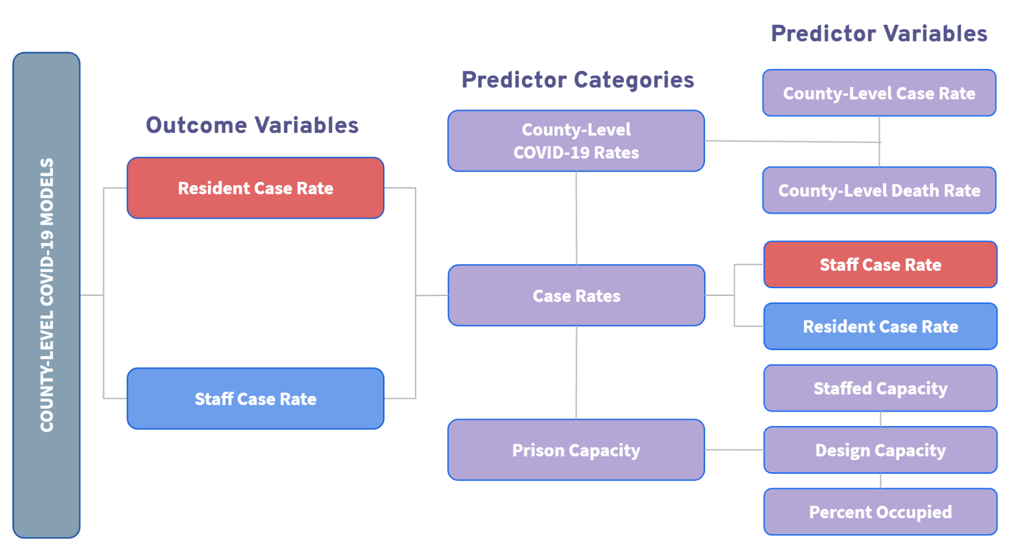

*Fig 8: Schematic of Hierarchical Regression Models with County-Wide COVID-19 Predictors*

After studying the effects of demographic predictors on prison case rates, we also wanted to see if there was a relationship between county-level covid rates and prison-level covid rates. We followed the same process as the demographic models, although this time the demographic category is replaced with a county-level covid rates category which contains county-level case and death rates, as shown in Figure 8.

###### **Bayesian generalized linear mixed effects, repeated measures models:**

Our second round of models assumed a Bayesian framework to model cumulative resident case counts with two different distributions: Gaussian and Poisson.

Bayesian models are grounded in calculating a posterior distribution from a hypothesized distribution, a set of priors (also in the form of conjugate distributions), and a dataset.

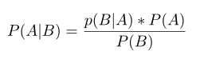

*Equation 1: Bayes Rule for probability of events A and B*

For a continuous distribution whose parameter is 𝜇, this calculation looks like:

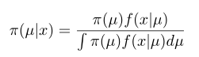

*Equation 2: Bayes Rule for calculating the posterior distribution*

Where π(µ) is the prior distribution, f(x|µ) is the probability distribution function of the hypothesized distribution, and ∫π(µ)f(x|µ)dµ is the marginal distribution. Bayesian models are powerful for their ability to take into account prior knowledge of distributions when calculating posterior distributions from sample data. Due to the complexity of the distributions being modelled, these integrals must be estimated using Markov chain - Monte Carlo simulations, which generate a series of parameter estimates, each with observable confidence intervals.

Testing a Poisson distribution was a logical fit for this type of cumulative case count data, as poisson distributions are often used to model disease spread. Because our previous well-fitting models included a Gaussian distribution assumption, it was also logical to compare Gaussian and Poisson distributions in order to optimize performance.

A secondary goal of the poisson distribution was to factor in the effects of time on cumulative case count. As our exploratory analysis shows, there is a clear relationship between time and case count (see Figure 12), so including this variable in the model should produce more accurate estimates of the effects of our other predictor variables.

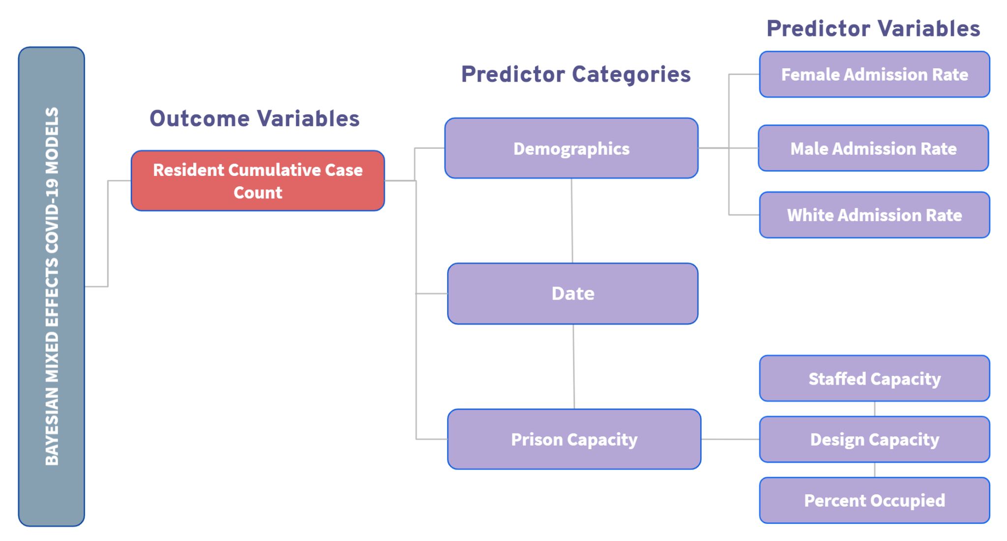

*Fig 9: Variable Schematic of Bayesian Regression Models*

In order to reduce the computational intensity of the Bayesian algorithms, we refined the number of facilities and narrowed the time frame to only include the second wave of COVID-19 infections in California. We chose facilities by randomly selecting 15 o f the 33. We estimated the dates of the second wave according to Johns Hopkins, who estimated it takes six to eight weeks after an incident of infection or policy changes for those changes to be reflected in data collection (*How Rates of COVID-19 Infection Produce Data Spikes*). Therefore, I estimated the start of the second wave as occurring 56 days (or roughly 8 weeks) before the date of highest daily change in cumulative resident cases (see Figure 10). These changes had a very small effect on the a priori power analysis of these models (see supplementary Table 8), so we concluded it was safe to proceed with the reduced sample size.

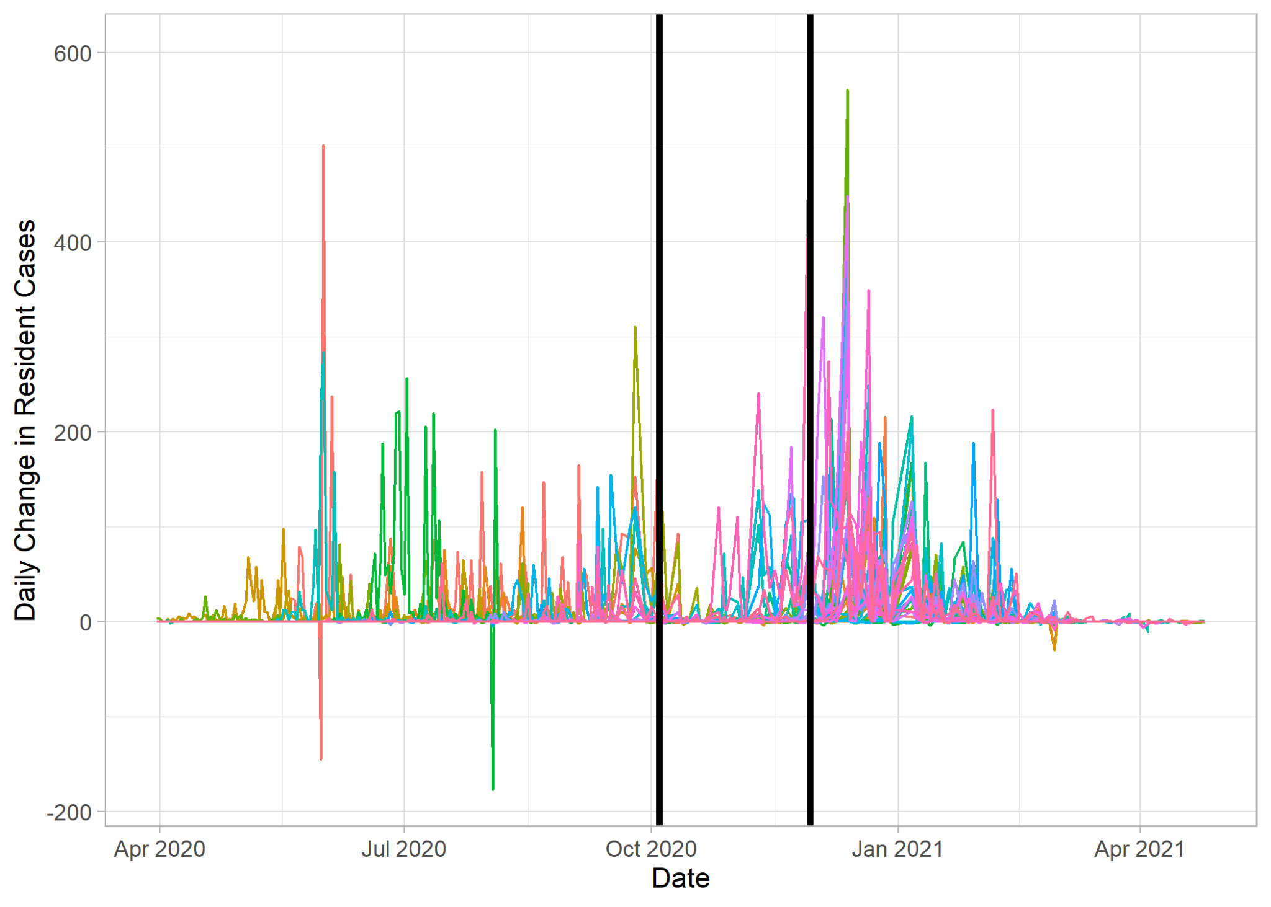

*Fig 10: Visualizing the Second Wave of COVID-19 Infections by Daily Change in Cumulative Resident Case Count (peak daily change is the right-most black line and 56 days before that is the left-most black line)*

#### **Summary of Results**

###### **Hierarchical multiple linear regression models:**

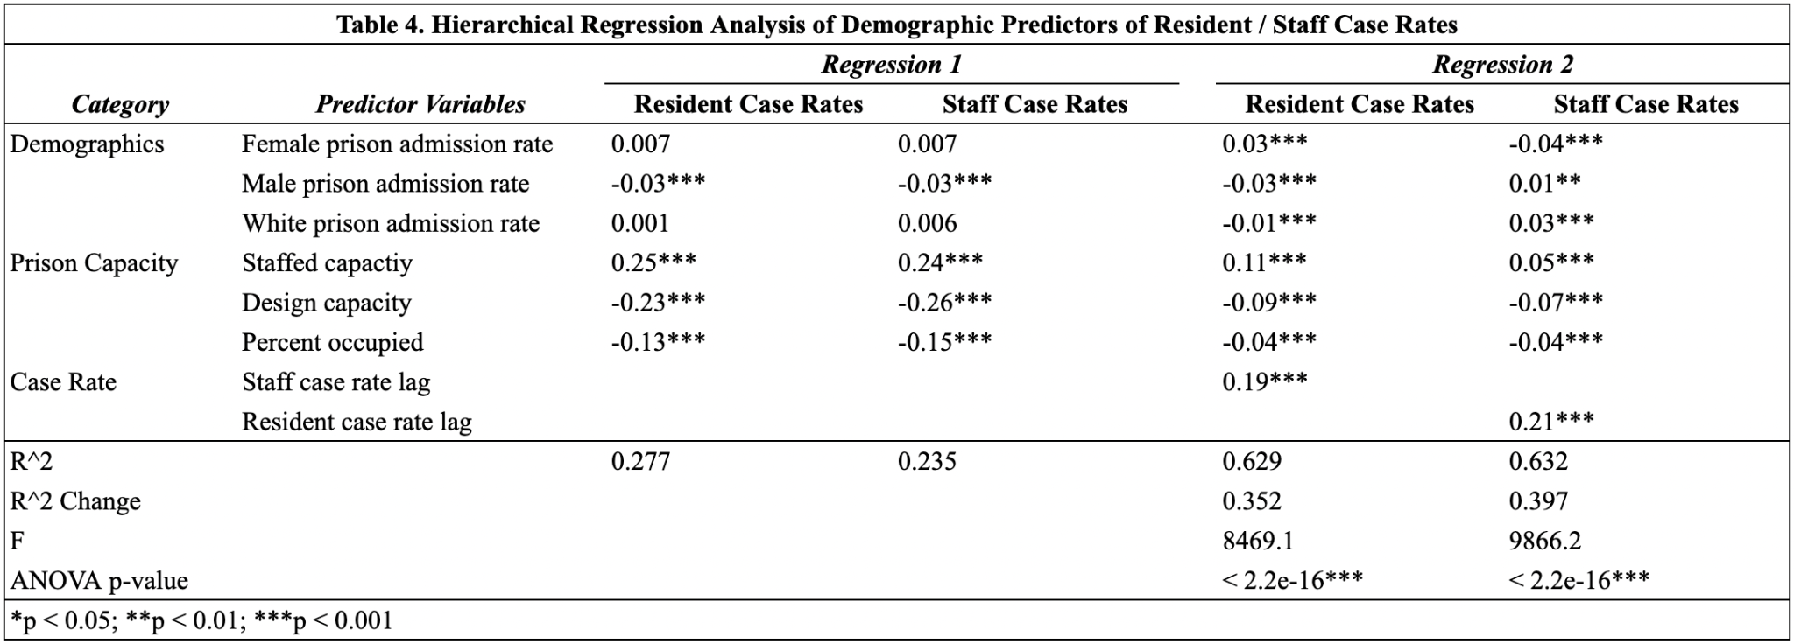

In Table 4, Regression 1 shows multiple linear regression models with just the demographic and prison capacity variables as predictors, and Regression 2 shows the same model with the lagged case rate predictors added. We do want to note that our predictor variables are standardized, so the coefficients reflect how much the outcome variable changes given a one standard deviation increase in the predictor variable. The model diagnostic plots for all of the models look good - the residuals are fairly randomly scattered and the errors are fairly normal - so our models are valid for analysis (see supplementary figures 11-14).

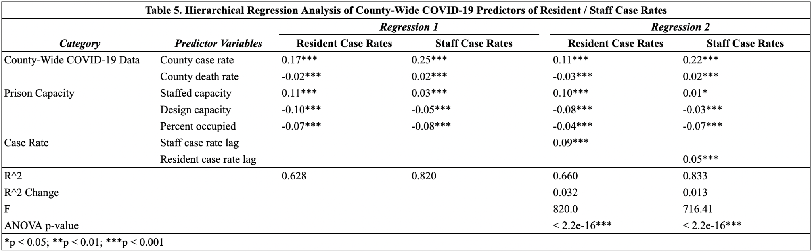

Table 5 shows the hierarchical regressions with the county-wide COVID-19 predictors. Again, the model diagnostic plots look good, so our models are valid for analysis (see supplementary figures 15-18).

###### **Bayesian generalized linear models:**

The final Bayesian models were mixed effects, repeated measures regressions predicting cumulative resident case count. Of the final six models, three test Gaussian distributions and three test Poisson distributions. Each distribution family includes the following regressions:

*(1P and 1G) Cumulative Resident Case Count ~ Date + Staffed Capacity + Percent Occupied + (Facility)*

*(2P and 2G) Cumulative Resident Case Count ~ Date + Staffed Capacity + Percent Occupied + White Prison ADM Rate + (Facility)*

*(3P and 3G) Cumulative Resident Case Count ~ Date + Staffed Capacity + Percent Occupied + White Prison ADM Rate + Male Prison ADM Rate + Female Prison ADM Rate + (Facility)*

All of the models investigate the effects of individual prisons by including random effects of the 15 facilities.

Table 6 shows the model coefficients for the final six models. Poisson coefficients are recorded in units of log case counts and Gaussian coefficients are recorded in case counts. Significant coefficients are those whose 90% observed confidence intervals did not cross 0.

*Table 6: Summary of Bayesian general linear mixed effects, repeated measures regressions*

|  |  | ***Poisson*** | | |  | ***Gaussian*** | | |
| --- | --- | --- | --- | --- | --- | --- | --- | --- |
| ***Category*** | ***Predictor Variables*** | **Model 1P** | **Model 2P** | **Model 3P** |  | **Model 1G** | **Model 2G** | **Model 3G** |
|  | Date | 0.01636 * | 0.0163627 * | 0.016361 * |  | 8.33144 * | 8.3134448 * | 8.331639 * |
| Prison Capacity | Staffed capacity | 0.00130 * | 0.0012986 * | 0.001299 * |  | 1.841175 * | 1.8620119 * | 1.9171007 * |
|  | Percent occupied | 0.06418 * | 0.0641654 * | 0.064162 * |  | -5.329827 * | -5.375001 * | -5.2910228 * |
| Demo-  graphics | Female prison admission rate |  |  | -0.635003 |  |  |  | -885.735711 * |
|  | Male prison admission rate |  |  | 0.627919 |  |  |  | 349.43010 |
|  | White prison admission rate |  | 0.04954 | 0.034408 |  |  | -55.27126 | 439.38452 |
| Prison Random Effects | Avenal State Prison | 0.59078 | 0.51767 | 0.962474 |  | 279.76273 | 346.62974 | 1,083.65713 |
|  | California Health Care Facility | 1.043456 * | 1.05990 * | 0.524404 |  | 149.64156 | 150.44564 | -374.56551 |
|  | California Institution for Women | 4.69458 * | 4.67370 * | 4.273346 * |  | 2748.8232 * | 2814.4588 * | 2372.17107 * |
|  | California State Prison, Los Angeles | 0.22779 | 0.31070 | 0.392924 |  | 162.41430 | 81.32917 | 496.10532 |
|  | California State Prison, San Quentin | 2.64049 * | 2.7547 * | 3.210861 * |  | 164.29206 | 28.90636 | 538.71932 |
|  | California State Prison, Solano | -2.46627 * | -2.40459* | -2.495324 * |  | -1308.3575* | -1375.9121 * | -1413.8501 * |
|  | Calipatria State Prison | -1.15227 * | -1.12709 * | -0.980430 |  | -109.50192 | -124.31734 | -396.92207 |
|  | Centinela State Prison | -1.27378 * | -1.24896 * | -1.101757 |  | 3.21836 | -11.33818 | -285.65136 |
|  | Chuckawalla Valley State Prison | 3.32485 * | 3.35240 * | 3.233606 |  | 2,828.30704 | 2827.0909 * | 2680.978 * |
|  | Correctional Training Facility | -2.02044 * | -1.9596 * | -1.972524 * |  | -2404.5598 * | -2,491.72796 | -2459.8033 * |
|  | Deuel Vocational Institution | 0.79194 * | 0.80819 | 0.272350 |  | 1390.6831 * | 1404.67018 * | 917.75587 * |
|  | Ironwood State Prison | -1.01896 * | -0.99113* | -1.109663 * |  | 171.92850 | 157.91938 | -28.69573 |
|  | North Kern State Prison | 0.23183 | 0.19099 | -0.174219 |  | -1,382.36322 | -1337.61339 * | -1968.71968 * |
|  | Pelican Bay State Prison | -0.33394 | -0.32653 | 0.367219 |  | -274.84905 | -269.43109 | 252.11600 |
|  | Substance Abuse Treatment Facility | -1.51645 * | -1.58921* | -1.144587 |  | -2,116.22975 | -2,058.69597 | -1,351.75279 |
| ELPD |  | -45,587.00 | -45,558.00 | -45,599.00 |  | -5,289.00 | -5,289.00 | -5,288.00 |
| Note: | Significance (*) determined as having 90% observed intervals which do not cross 0 | | | | | | | |

#### **Interpretation of Results**

###### **Hierarchical multiple linear regression models:**

Table 4 shows that the demographic variables are significantly related to resident and staff case rates when the lagged case rates are added to the models in Regression 2, but do not seem to have as strong of effects on their own. In Regression 2, we see that prisons with higher male and White admission rates are associated with lower resident case rates, and higher female admission rates are associated with higher resident case rates, but the opposite is true for staff case rates.

All of the prison capacity variables are significant across all models and outcome variables, so capacity seems to have a strong relationship with both resident and staff case rates. However, one interesting finding is that the coefficients for percent occupied are negative, meaning an increase in the percentage occupied in the prison results in a decrease in resident / staff case rates.

We can also see that adding the lagged case rates as predictors increases the $R^{2}$ of both models significantly, by well over 30% for both of them. In addition, we conducted ANOVA tests to see if adding the respective case rate predictor variable to the model results in a significant change for each outcome variable, and got significant p-values for both tests. This aligns with our cross-correlation analysis from earlier that showed a clear relationship between staff and resident case rates.

There also seems to be a very strong relationship between the county-level COVID-19 statistics and prison-level case rates, as shown in Table 5. This makes intuitive sense, especially for staff case rates as the outcome variable, as prison staff likely reside within the county community and would have similar instances of COVID-19 as the county-level cases. Interestingly, higher county-wide death rates are associated with lower resident case rates, but the same is not true for staff.

The $R^{2}$ values are already really high for Regression 1 and don’t increase by a lot when adding in the lagged case rates as predictors. However, conducting an ANOVA test still determines that adding in these case rate variables results in a significant change in the outcome, with p-values approximately equal to 0.

Similarly to the demographic models, the prison capacity variables are still significant across the models in Table 5, although staffed capacity is not nearly as significant in Regression 2 with staff case rates as the outcome. We also still see negative coefficients for percent occupied, meaning that prisons with higher percentage occupied result in lower resident / staff case rates.

###### **Bayesian generalized linear models:**

Of the two families of models, Poisson regression performed the best. This is based upon posterior predictive checks for goodness of fit. These plots compare the posterior distributions – which were fit on random samples of data – to the true distribution of cumulative case count. The closer the randomly generated distributions (seen in supplementary Figures 19 and 20 in light blue) are to the true distribution (in black), the better the goodness of fit. Therefore, it is clear from supplementary Figure 19 the Poisson distribution is a better fit.

Among the three Poisson models, ELPD is inconclusive regarding which model is superior. ELPD (expected log pointwise predictive density) is a numerical goodness of fit metric for Bayesian models which calculates on average how good the posterior distribution is at fitting new data. An common arbitrary threshold is 4 points of difference to signify significantly different models. However, all three poisson models are within one or two points of each other (see Table 6), leaving us unable to draw conclusions about which model performs best.

However, we can draw conclusions about the significance of most of our predictors, as all three Poisson models agree on the significance of date, staffed capacity, and percent occupied. The Gaussian models also agreed on these three variables, finding them all to be significant. Cumulative resident case counts increased as time progressed and were higher for facilities with higher staffed capacities.

However, the distributions disagreed about the effect of percent occupied on cumulative case count. The gaussian models uniformly concluded an increase in percent occupied decreased cumulative resident case count by 5.33195 ± .041 counts on average. By contrast, the Poisson models uniformly predicted a 0.064169 ± -1.087e-05 increase in log cumulative case count per percent increase in percent occupied. This corresponds with a 1.066273 count increase in cumulative case count for every percent increase in percent occupied.

One potential reason for this difference could be because poisson models cannot predict a decrease in cumulative case count due to the nature of the poisson distribution: its output is always positive. Therefore, even negative coefficients predict some magnitude of positive change.

Nonetheless, if we continue with the conclusion that the Poisson distribution is the best fitting distribution, then we must conclude the relationship between cumulative resident case count and percent occupied is positive and statistically significant.

| Above Average | Below Average |
| --- | --- |
| California Institution for Women  California State Prison, San Quentin  Deuel Vocational Institution  Chuckawalla Valley State Prison | Correctional Training Facility  California State Prison, Solano |

*Table 7: Prisons above or below average cumulative case count for three or more models*

Finally, all six models show interesting patterns among the most significant facility-level effects. Table 7 shows the facilities which were significantly above or below average in 3 or more models and across both distributions. These individual prison effects were not reflected in any of the significant predictor variables in any of our models, so there must exist confounding variables which explain this consistent variation.

#### **Overall Conclusions**

To summarize our analysis, let’s go back to our initial research questions:

1. How are criminal justice outcomes reflected through COVID-19?

First, we saw that spread rates were higher in the Adelanto ICE Processing Center than at the county-level through our R0 analysis. Although these results cannot be generalized to all prison facilities within California, this still flags an important topic to look into how COVID-19 spreads in smaller spaces compared to large ones.

Through our hierarchical regression models, we saw that demographics, county-wide COVID-19 statistics, and prison capacity are significantly and differentially related to case rates in prisons. Prisons with higher male and White admission rates are associated with lower resident case rates, and higher female admission rates are associated with higher resident case rates, but the opposite is true for staff case rates. Higher county-wide COVID-19 rates are associated with higher rates in prison facilities as well, although higher county-wide death rates are associated with lower resident case rates. For staff, the opposite is true. We also saw that prison facilities with higher percentage occupied had lower resident and staff case rates.

Our Bayesian mixed-effects analysis uncovered significant prison-to-prison effects which were not explained by prison characteristics like capacity or percent occupied. While we ultimately concluded cumulative case rates are Poisson distributed, facilities with higher percent occupations had higher COVID-19 case counts, and staffed capacity was associated with higher case counts, there are clearly other variables leading to COVID-19’s effects being unevenly distributed across the state prisons in California. Therefore, further research is required to understand these uneven outcomes and what some prisons have done to achieve lower than average case counts.

1. How are prisons similar to universities in the context of COVID-19?

From our cross-correlation analysis, we saw that prison staff are the ones infecting residents which could mean in universities, if quarantine measures are in place, we should be aware of the potential for those living off campus to infect those within. In addition, through our Bayesian modeling, we saw that more crowded facilities are not necessarily connected with higher COVID-19 case counts, suggesting some facilities may be better equipped to handle a pandemic, regardless of size.

Therefore, as schools plan to open at higher capacities for in person instruction and extend invitations for housing, it’s imperative to understand how COVID-19 spreads in smaller spaces and better consider the risks it poses. Since prisons and dorm rooms have similar living situations, specifically with roommates and staff interactions, our findings may provide insight on the interrelation between COVID-19 and student housing. Since our analysis shows a strong trend of staff and resident cases predicting each other, the Department of Housing may apply this information to implement extra precautions in residence halls to deter the spread of COVID-19 between roommates, staff, and other residents.

#### **Challenges of the Study**

Due to the scarcity of jail data, our group wasn’t able to compare the spread of COVID-19 between prisons and jails nor apply this research to jail facilities. We also had very limited data on resident and staff deaths, so our group wasn’t able to apply our analysis to resident and staff death rates. Our prison demographic data was only from 2010 to 2016 and aggregated to the county-level, so the demographic information we used is not recent, and is not at the facility-level which would be ideal. Since COVID-19 is a new and ongoing virus, the data continues to evolve, which leads to ever-changing results. Furthermore, factors such as misreporting of data and inaccurate tests during the early stages of transmission could mean the data could be misleading. Due to the lack of time and resources, our group could only observe COVID-19 data in California prison facilities in select counties, so these results are not representative of the entire United States.

#### **Recommendations for the Future**

With more time and data, we foresee our project being expanded to conduct the same analysis we have performed on resident and staff case rates on resident and staff death rates. Our R0 modeling could be extended to more facilities to investigate how our variables of interest influence prison infection rates. We could also compare the infection rates across different counties and facilities, stretching past focusing on one. A future expansion of Bayesian generalized linear models with regard to this project could include informative priors in all the Bayesian models based on a growing pool of COVID-19 research, and could cover additional prison characteristics (e.g. average room occupancy, average prisoner turnover, medical resources, etc.) to better understand the significant prison-to-prison variation present in our current Bayesian models. Since this project stayed within California, future analysis could incorporate facilities outside of the state and compare national findings with our current results. Finally, we would recommend creating an interactive dashboard to incorporate all these additional recommendations and visualize analyses with interactive plots and maps that demonstrate prison resident and staff case rates, deaths, and spread.

#### 

#### **Supplementary Figures**

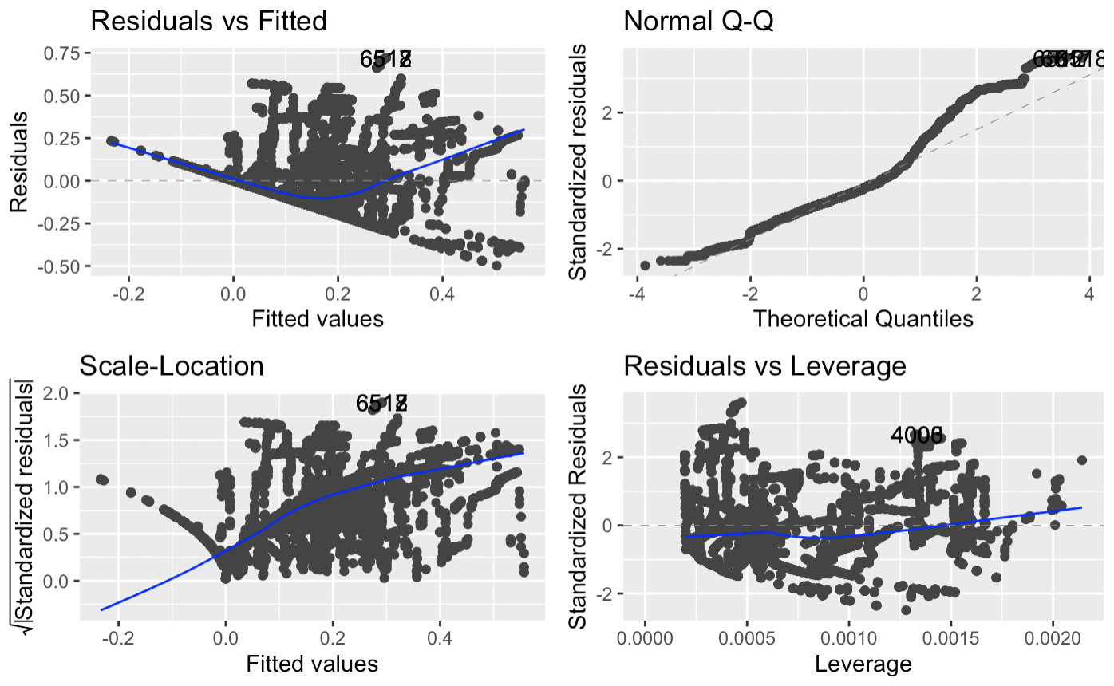

*Figure 11: Model diagnostic plots of demographic model Regression 1 with resident case rates as outcome*

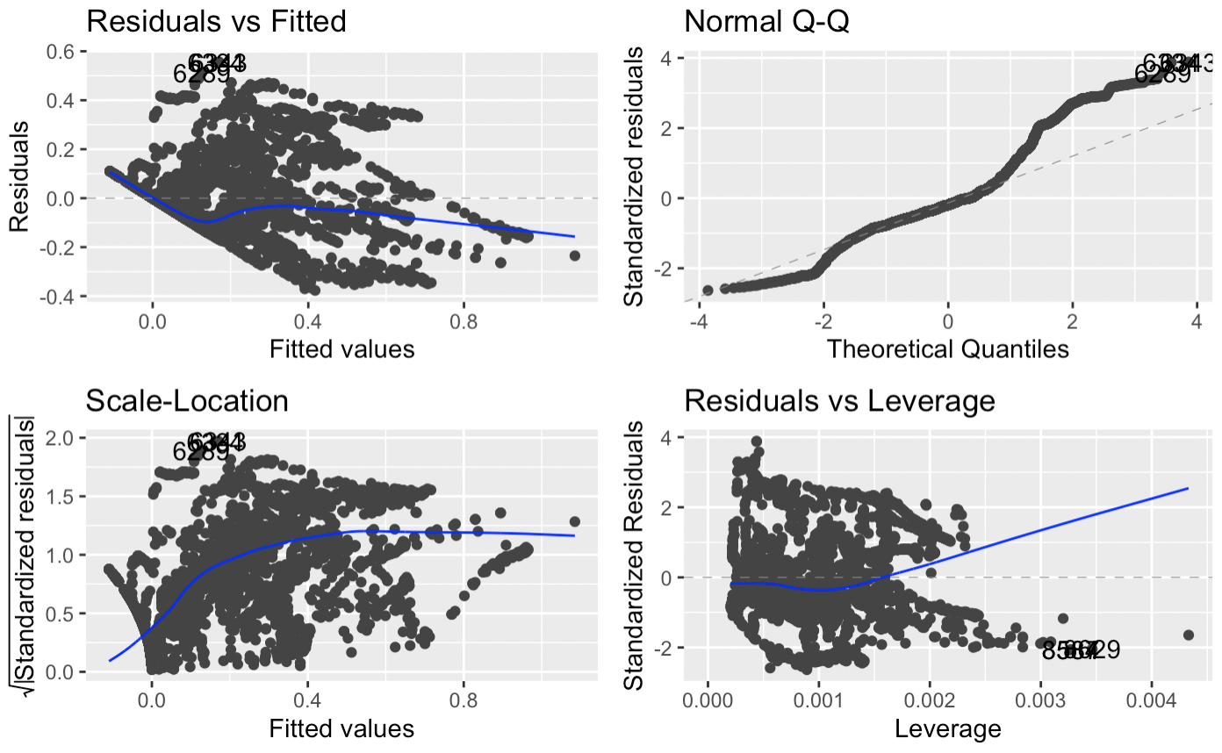

*Figure 12: Model diagnostic plots of demographic model Regression 2 with resident case rates as outcome*

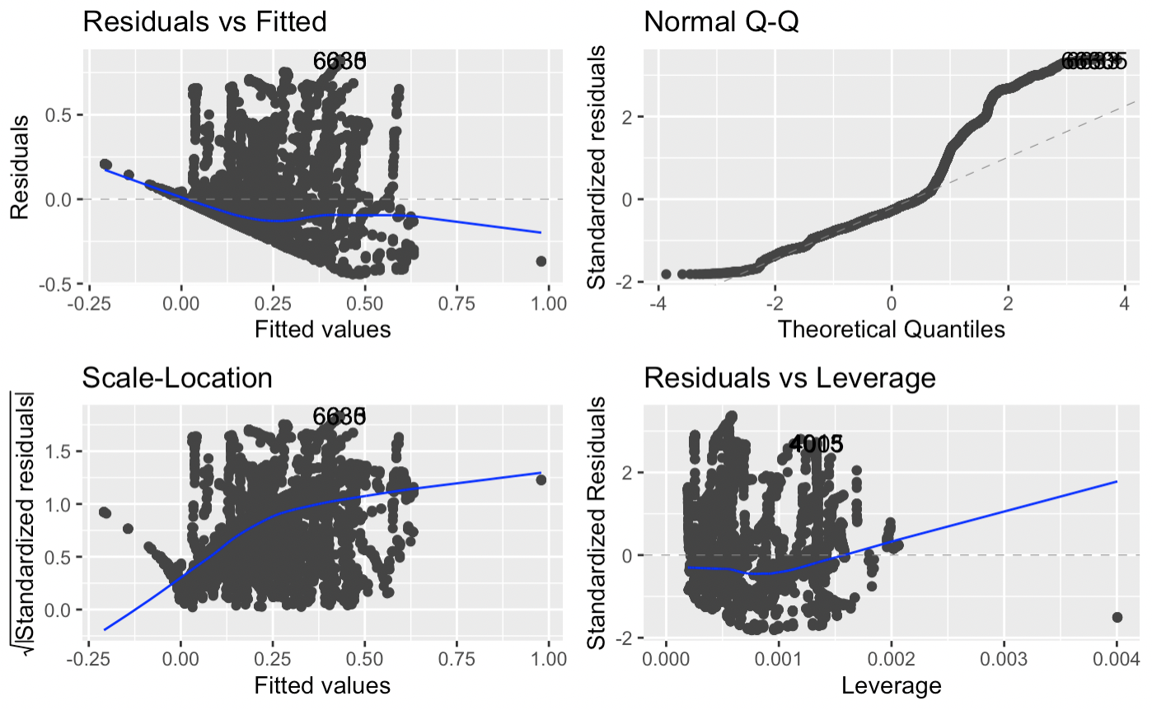

*Figure 13: Model diagnostic plots of demographic model Regression 1 with staff case rates as outcome*

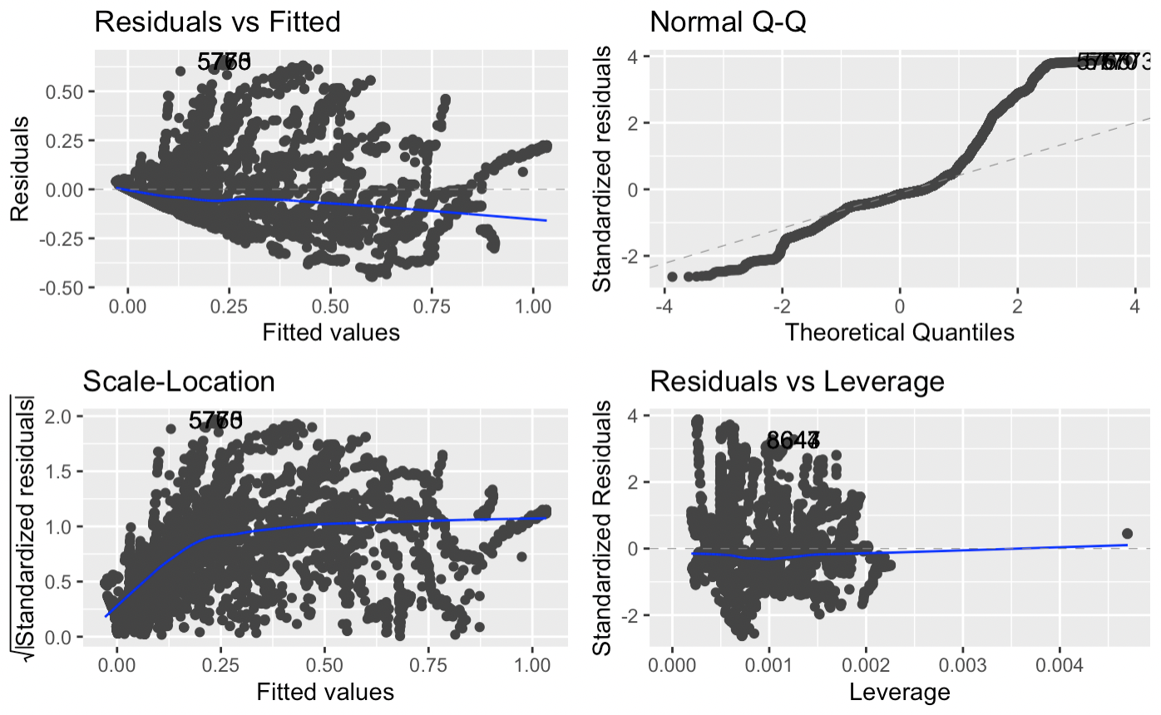

*Figure 14: Model diagnostic plots of demographic model Regression 2 with staff case rates as outcome*

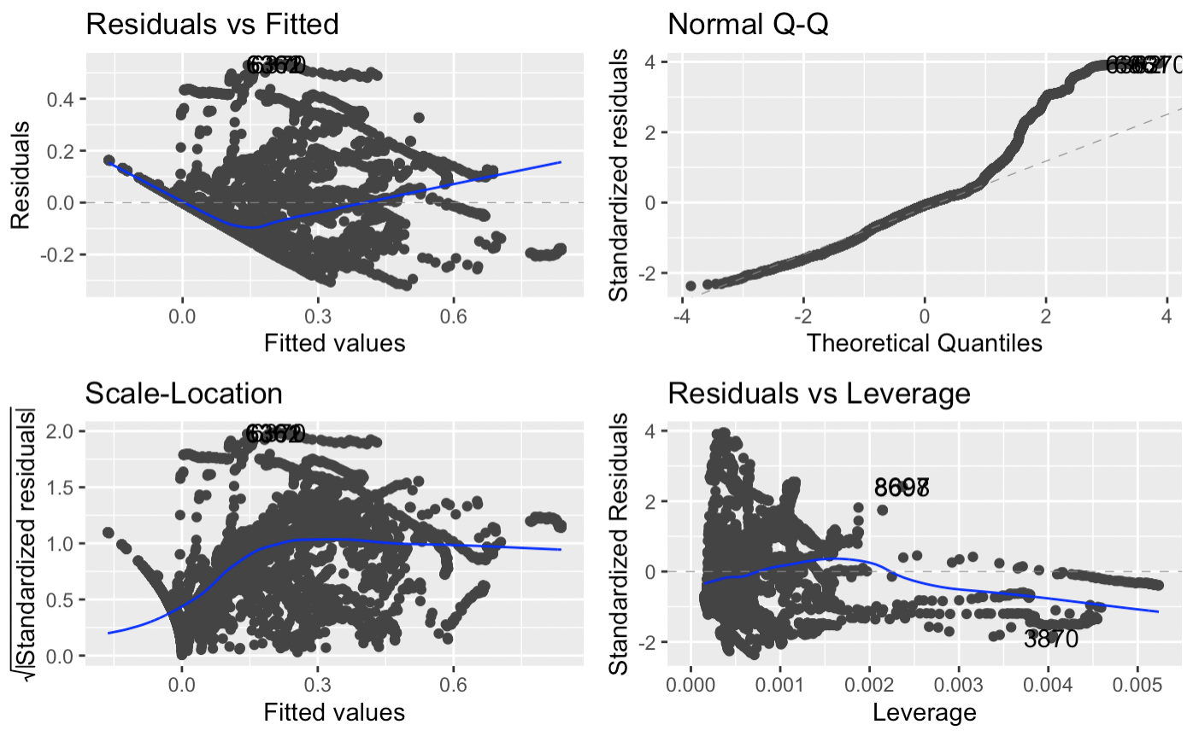

*Figure 15: Model diagnostic plots of COVID-19 model Regression 1 with resident case rates as outcome*

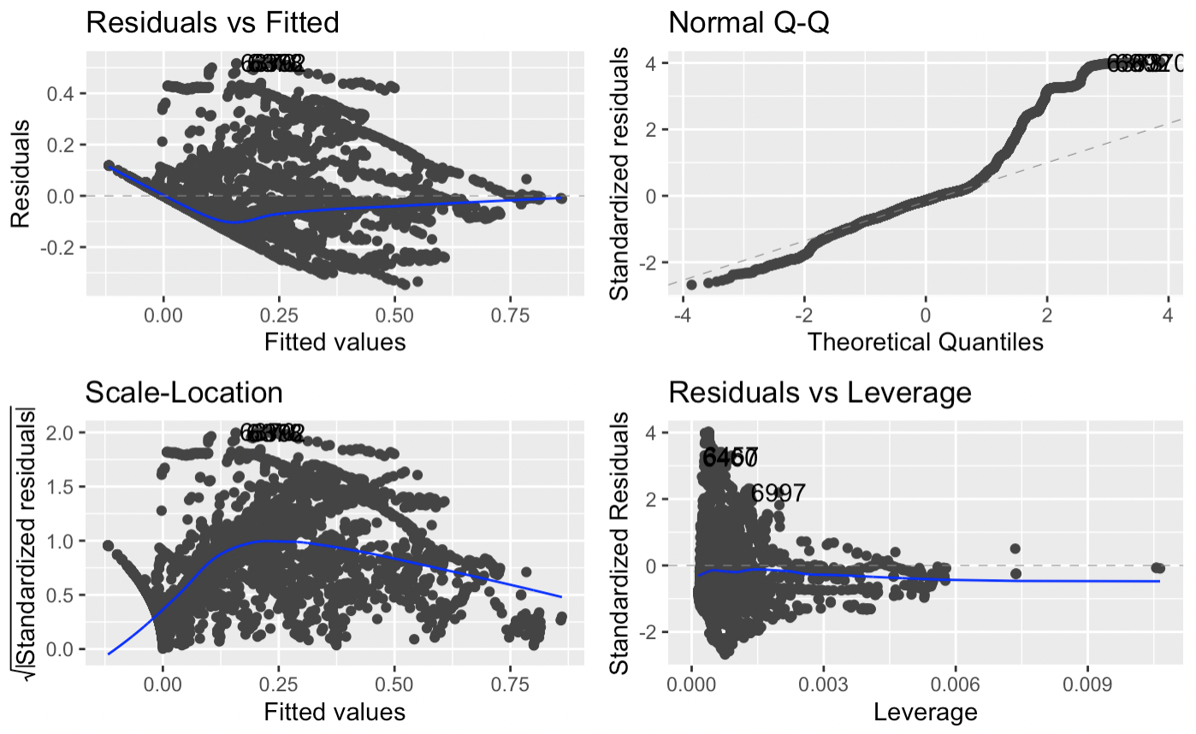

*Figure 16: Model diagnostic plots of COVID-19 model Regression 2 with resident case rates as outcome*

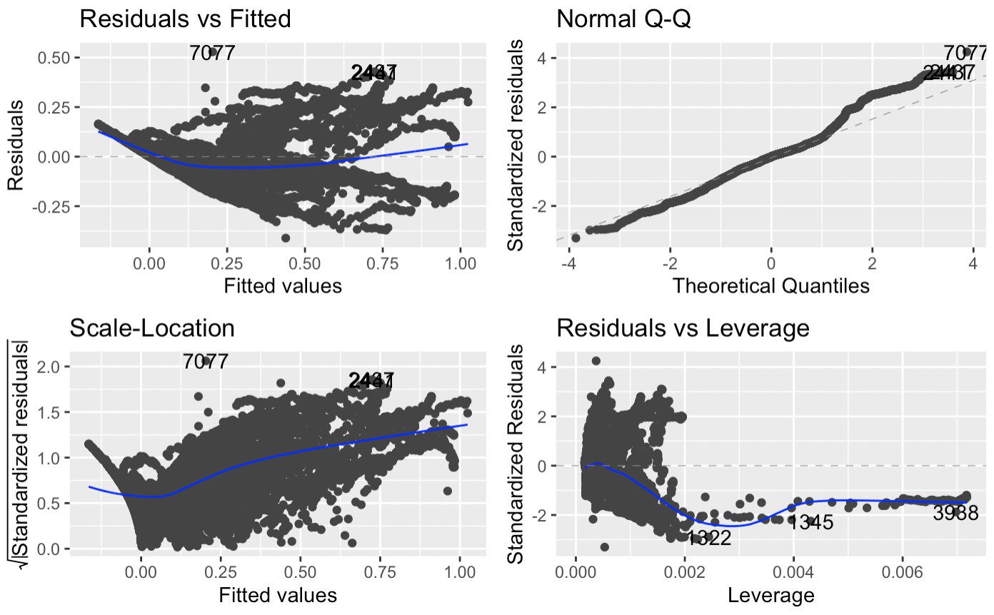

*Figure 17: Model diagnostic plots of COVID-19 model Regression 1 with staff case rates as outcome*

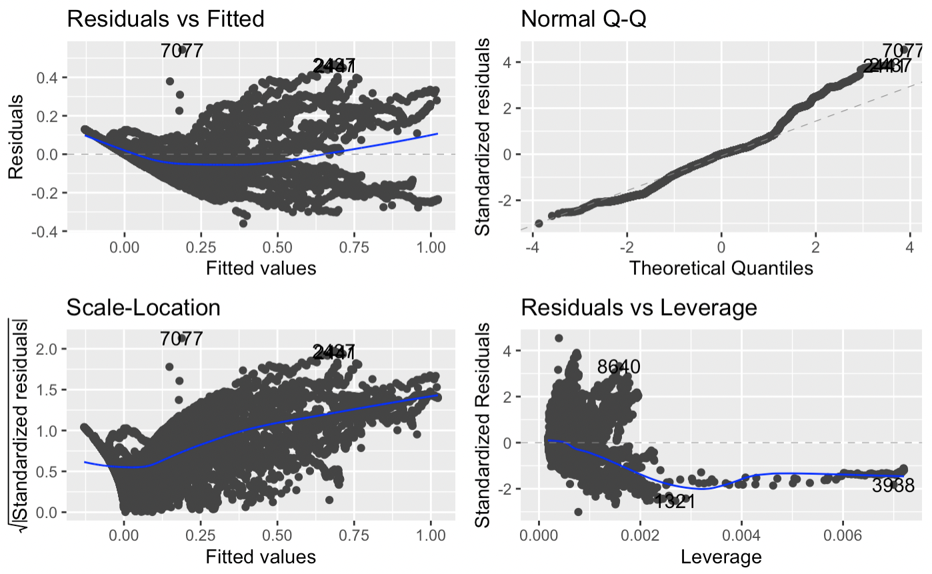

*Figure 18: Model diagnostic plots of COVID-19 model Regression 2 with staff case rates as outcome*

| Effect Size | .01 | .001 | .0001 |
| --- | --- | --- | --- |
| Actual Power | 0.9507112 | 0.9500089 | 0.9499999 |
| α error probability = 0.05 , Power (1 - β) = 0.95 , Number of Groups = 15, Number of Measurements = 288, Correlation among repeated measures = 0.5, Nonsphericity correction = 1 | | | |

*Table 8: Predicted power for different effects sizes. (Calculated using GPower for repeated measures ANOVA with mixed effects.)*

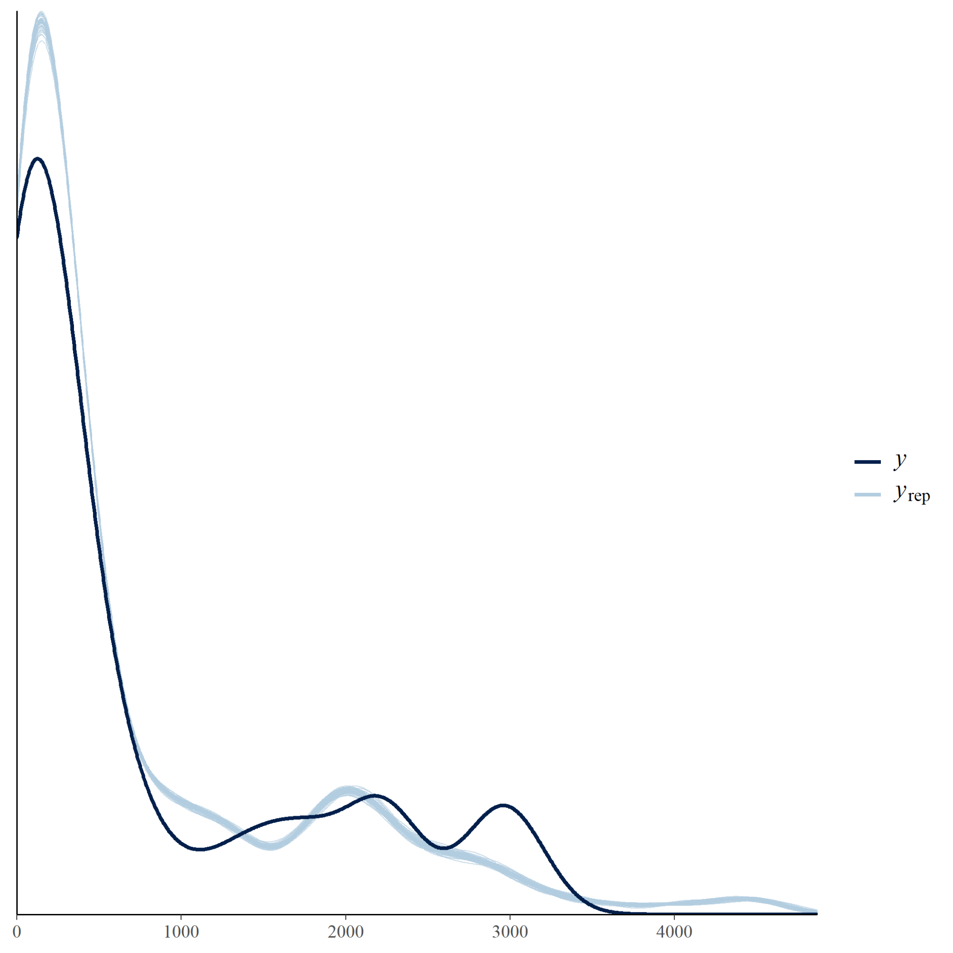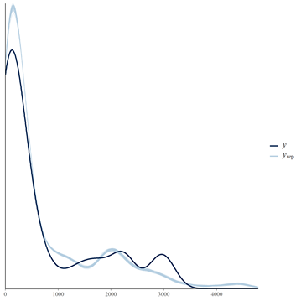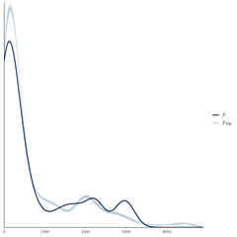

*Figure 19: Posterior predictive checks of the three Bayesian Poisson regressions. Blue lines are the simulated posterior distributions and the black lines are the true distribution of the outcome variable: cumulative resident case count. From right to left Model 1P, 2P and 3P.*

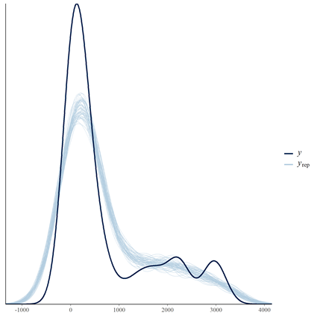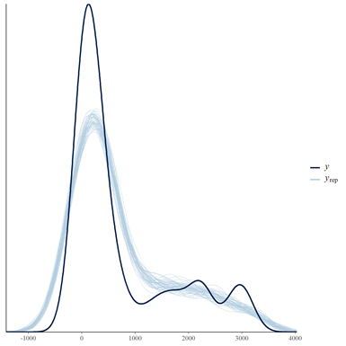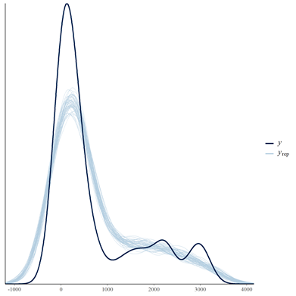

*Figure 20: Posterior predictive checks of the three Bayesian Gaussian regressions. Blue lines are the simulated posterior distributions and the black lines are the true distribution of the outcome variable: cumulative resident case count. From right to left Model 1G, 2G and 3G.*

#### **Resources**

Chan, Stephen, et al. “Count Regression Models for COVID-19.” *Physica a*, vol. 563, Feb. 2021, p. 125460. *PubMed Central*, doi:[10.1016/j.physa.2020.125460](https://doi.org/10.1016/j.physa.2020.125460).

Cori, Anne. *Estimate Time Varying Reproduction Numbers from Epidemic Curves [R Package EpiEstim Version 2.2-4]*. Comprehensive R Archive Network (CRAN), 7 Jan. 2021, [https://CRAN.R-project.org/package=EpiEstim](https://cran.r-project.org/package=EpiEstim).

*COVID-19 Time-Series Metrics by County and State - Statewide COVID-19 Cases Deaths Tests - California Open Data*. <https://data.ca.gov/dataset/covid-19-time-series-metrics-by-county-and-state1/resource/6a1aaf21-2a2c-466b-8738-222aaceaa168>. Accessed 4 June 2021.

Fong, Edith Garcia. *California’s Proposition 47: The Safe Neighborhoods and Schools Act*. San Jose State University, 1 May 2020. *DOI.org (Crossref)*, doi:[10.31979/etd.3sac-8xbz](https://doi.org/10.31979/etd.3sac-8xbz).

*Hierarchical Linear Regression | University of Virginia Library Research Data Services + Sciences*. <https://data.library.virginia.edu/hierarchical-linear-regression/>. Accessed 4 June 2021.

*How Rates of COVID-19 Infection Produce Data Spikes*. <https://www.hopkinsmedicine.org/health/conditions-and-diseases/coronavirus/how-rates-produce-data-spikes>. Accessed 4 June 2021.

Iftimie, Simona, et al. “First and Second Waves of Coronavirus Disease-19: A Comparative Study in Hospitalized Patients in Reus, Spain.” *PLOS ONE*, vol. 16, no. 3, Public Library of Science, Mar. 2021, p. e0248029. *PLoS Journals*, doi:[10.1371/journal.pone.0248029](https://doi.org/10.1371/journal.pone.0248029).

*Index of /Scraper_data/Summary_data/*. <http://104.131.72.50:3838/scraper_data/summary_data/>[scraped_time_series.csv](http://104.131.72.50:3838/scraper_data/summary_data/scraped_time_series.csv). Accessed 4 June 2021.

Initiative, Prison Policy. *Since You Asked: Is Social Distancing Possible behind Bars?* <https://www.prisonpolicy.org/blog/2020/04/03/density/>. Accessed 4 June 2021.

---. *Since You Asked: Just How Overcrowded Were Prisons before the Pandemic, and at This Time of Social Distancing, How Overcrowded Are They Now?* <https://www.prisonpolicy.org/blog/2020/12/21/overcrowding/>. Accessed 4 June 2021.

Looi, Mun-Keat. “Covid-19: Is a Second Wave Hitting Europe?” *BMJ*, vol. 371, British Medical Journal Publishing Group, Oct. 2020, p. m4113. *www.bmj.com*, doi:[10.1136/bmj.m4113](https://doi.org/10.1136/bmj.m4113).

“(PDF) A New Framework and Software to Estimate Time-Varying Reproduction Numbers During Epidemics.” *ResearchGate*. *www.researchgate.net*, doi:[10.1093/aje/kwt133](https://doi.org/10.1093/aje/kwt133). Accessed 4 June 2021.

*Program_fact_sheet_201907.Pdf*. <https://www.bop.gov/about/statistics/docs/program_fact_sheet_201907.pdf>. Accessed 4 June 2021.

Rai, Balram, et al. “Estimates of Serial Interval for COVID-19: A Systematic Review and Meta-Analysis.” *Clinical Epidemiology and Global Health*, vol. 9, 2021, pp. 157–61. *PubMed Central*, doi:[10.1016/j.cegh.2020.08.007](https://doi.org/10.1016/j.cegh.2020.08.007).

United States Department Of Justice. Office Of Justice Programs. Bureau Of Justice Statistics. *Census of Jails, 2013: Version 4*. Inter-University Consortium for Political and Social Research, 2015. *DOI.org (Datacite)*, doi:[10.3886/ICPSR36128.V4](https://doi.org/10.3886/ICPSR36128.V4).

*Vera-Institute/Incarceration-Trends*. 2018. Vera Institute of Justice, 2021. *GitHub*, <https://github.com/vera-institute/incarceration-trends/blob/ae6a18945c23b56aa8d4b00ff83090d83a171fac/incarceration_trends_jail_jurisdiction.csv>.